TASK: LED SEQUENCE V3.0

AUTHOR: MOHAMMED ABDEL-WAHAB

**DESCRIPTION**:

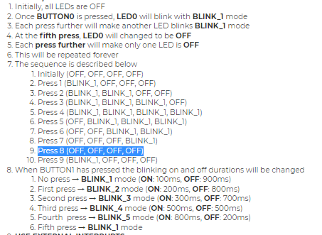

**Layere Architecture:**

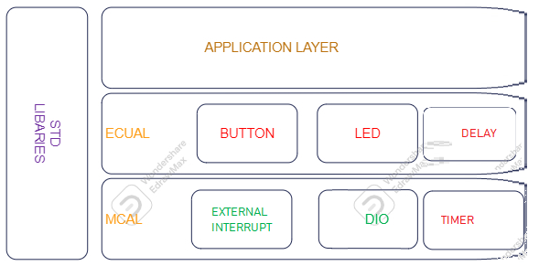

**State machine diagram for the LED SEQUANCE OF THE APPLICATION:**

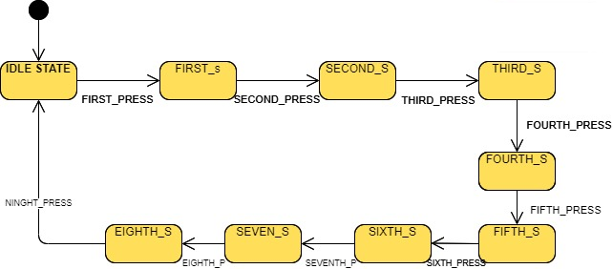

* IDLE STATE: ALL LEDS ARE OFF
* FIRST STATE: LED 0 IS ONLY BLINKING
* SECOND STATE: LED 0 & LED 1 ARE BLINKING
* THIRD STATE : LED 0 & LED 1 & LED 2 ARE BLINKING
* FOURTH STATE: ALL LEDS ARE BLINKING
* FIFTH STATE: LED 0 IS ONLY OFF
* SIXTH STATE: LED 0 & LED 1 ARE OFF
* SEVENTH STATE: LED 0 & LED 1 & LED 2 ARE OFF
* EIGHTH STATE: ALL LEDS ARE OFF

**State machine diagram for the LED BLINKING MODES OF THE APPLICATION:**

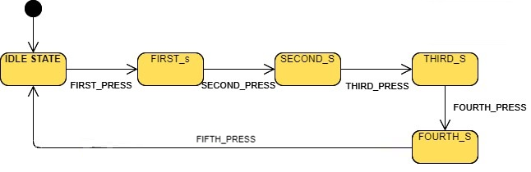

* IDLE STATE: No press → BLINK_1 mode (ON: 100ms, OFF: 900ms)
* FIRST STATE: First press → BLINK_2 mode (ON: 200ms, OFF: 800ms)
* SECOND STATE: Second press → BLINK_3 mode (ON: 300ms, OFF: 700ms)
* THIRD STATE : Third press → BLINK_4 mode (ON: 500ms, OFF: 500ms)
* FOURTH STATE: Fourth press → BLINK_5 mode (ON: 800ms, OFF: 200ms)
* FIFTH STATE: Fifth press → BLINK_1 mode

**ALL project APIs:**

DIO DRIVER APIs:

/**

* @brief Initialize the direction of specific pin @ref direction_t

* @param _pin_config A Reference of the pin configuration @pin_config_t

* @return status of the function

* E_OK :the function done successfully

* E_NOT_OK :the function has issues performing the function

*/

Std_ReturnType DIO_pin_direction_intialize(const pin_config_t *pin_config_ptr,direction_t a_direction);

/**

* @brief Write the logic of specific pin @ref logic_t

* @param _pin_config A Reference of the pin configuration @pin_config_t

* @param logic

* @return status of the function

* E_OK :the function done successfully

* E_NOT_OK :the function has issues performing the function

*/

Std_ReturnType DIO_pin_write_logic(const pin_config_t *pin_config_ptr,const logic_t a_logic);

/**

* @brief Read the logic of specific pin @ref logic_t

* @param _pin_config A Reference of the pin configuration @pin_config_t

* @param logic

* @return status of the function

* E_OK :the function done successfully

* E_NOT_OK :the function has issues performing the function

*/

Std_ReturnType DIO_pin_read_logic(const pin_config_t *pin_config_ptr, logic_t *logic_ptr);

/**

* @brief Toggle the logic of specific pin @ref logic_t

* @param _pin_config A Reference of the pin configuration @pin_config_t

* @return status of the function

* E_OK :the function done successfully

* E_NOT_OK :the function has issues performing the function

*/

Std_ReturnType DIO_pin_toggle_logic(const pin_config_t *pin_config_ptr);

/**

* @brief Initialize the direction of specific pin and Initialize its logic

* @param _pin_config A Reference of the pin configuration @pin_config_t

* @return status of the function

* E_OK :the function done successfully

* E_NOT_OK :the function has issues performing the function

*/

/*

Std_ReturnType DIO_pin_intialize(const pin_config_t *pin_config_ptr);

*/

/**

*

* @param port_index

* @param direction

* @return status of the function

* E_OK :the function done successfully

* E_NOT_OK :the function has issues performing the function

*/

Std_ReturnType DIO_port_direction_intialize(const port_index_t a_port_index, uint8_t a_direction);

/**

* @param port_index

* @param logic

* @return status of the function

* E_OK :the function done successfully

* E_NOT_OK :the function has issues performing the function

*/

Std_ReturnType DIO_port_write_logic(const port_index_t a_port_index , uint8_t a_logic);

/**

* @param port_index

* @param logic

* @return status of the function

* E_OK :the function done successfully

* E_NOT_OK :the function has issues performing the function

*/

Std_ReturnType DIO_port_read_logic(const port_index_t a_port_index , uint8_t *const a_logic_ptr);

/**

* @param port_index

* @return status of the function

* E_OK :the function done successfully

* E_NOT_OK :the function has issues performing the function

*/

Std_ReturnType DIO_port_toggle_logic(const port_index_t a_port_index);

LED DRIVER APIs:

/**

* @breif Initialize The led by configuring the pin as output and write low

* @param Led The reference of the led module configuration

* @return status of the function

* E_OK :the function done successfully

* E_NOT_OK :the function has issues performing the function

*/

Std_ReturnType LED_initialize(const led_t *led_ptr);

/**

* @breif Turn the led on

* @param led The reference of the led module configuration

* @return status of the function

* E_OK :the function done successfully

* E_NOT_OK :the function has issues performing the function

*/

Std_ReturnType LED_turn_on(const led_t *led_ptr);

/**

* @breif Turn the led off

* @param led The reference of the led module configuration

* @return status of the function

* E_OK :the function done successfully

* E_NOT_OK :the function has issues performing the function

*/

Std_ReturnType LED_turn_off (const led_t *led_ptr);

/**

* @breif Toggle the led

* @param led The reference of the led module configuration

* @return status of the function

* E_OK :the function done successfully

* E_NOT_OK :the function has issues performing the function

*/

Std_ReturnType LED_turn_toggle (const led_t *led_ptr);

BUTTON DRIVER APIs:

/**

* @breif Initialize The assigned pin to be input

* @param btn he reference of the button module configuration

* @return status of the function

* E_OK :the function done successfully

* E_NOT_OK :the function has issues performing the function

*/

Std_ReturnType BTN_init(const button_t *btn_ptr);

/**

* @breif Read the push button if is it pressed or released

* @param btn The reference of the button module configuration

* @param btn_state The reference of the variable that store the button status @ref button_status_t

* @return status of the function

* E_OK :the function done successfully

* E_NOT_OK :the function has issues performing the function

*/

Std_ReturnType BTN_read_state(const button_t *btn_ptr, button_status_t *btn_states_ptr);

EXTERNAL INTERRUPT APIs:

/*

* Description : Call the Call Back function in the application after the edge is detected

* @param A pointer to function & the external interrupt id

* @return status of the function

* E_OK :the function done successfully

* E_NOT_OK :the function has issues performing the function

*/

Std_ReturnType EXT_INTx_setCallBack(volatile void(*a_fptr)(void), const Interrupt_ID_t a_interrupt_number );

/*

* Description : initialize the the dio pin to be an external interrupt

* @param A Reference of the external interrupt configuration

* @return status of the function

* E_OK :the function done successfully

* E_NOT_OK :the function has issues performing the function

*/

Std_ReturnType EXT_INTx_Init(const Interrupt_Config_t *Interrupt_Config_Ptr );

/*

* Description : set the edge in which the external interrupt will be triggered

* @param edge type & the external interrupt id

* @return status of the function

* E_OK :the function done successfully

* E_NOT_OK :the function has issues performing the function

*/

Std_ReturnType EXT_INTx_setEdgeType(Interrupt_Edge_type_t a_edgeType , Interrupt_ID_t a_interrupt_Id);

/**

* @brief DeInitialize the interrupt module

* @param the external interrupt id

* @return Status of the a_interrupt_Id

* (E_OK) : The function done successfully

* (E_NOT_OK) : The function has issue to perform this action

*/

Std_ReturnType EXT_INTx_DeInit(const Interrupt_ID_t a_interrupt_Id);

TIMER DRIVER APIs:

/*

* Description: Function to Initialize Timer Driver

* - Working in Interrupt Mode

* - Choose Timer initial value

* - Choose Timer_ID (Timer0, Timer1, Timer2)

* - Choose Timer_Mode (OverFlow, Compare,PWM)

* - if using CTC mode choose Timer compare match value And choose output_compare_mode

*

*@param A Reference of the Timer configuration

* @return status of the function

* E_OK :the function done successfully

* E_NOT_OK :the function has issues performing the function

*/

Std_ReturnType TIMERx_init(const Timer_Config_t *stPtr_a_Config);

/*

* Description : START COUNTING BY CONFIGURE THE TIMER CLOCK

* @param A Reference of the Timer configuration

* @return status of the function

* E_OK :the function done successfully

* E_NOT_OK :the function has issues performing the function

*/

Std_ReturnType TIMERx_start(const Timer_Config_t *stPtr_a_Config);

/*

* Description : Call the Call Back function in the application after timer did its job

* @param A pointer to function & the timer type

* @return status of the function

* E_OK :the function done successfully

* E_NOT_OK :the function has issues performing the function

*/

Std_ReturnType TIMERx_setCallBack(volatile void(*a_fptr)(void), const TimerType_t en_a_timer_type );

/*

* Description :set a certain value on the timer counting register

* @param the timer type and the initial value to be set

* @return status of the function

* E_OK :the function done successfully

* E_NOT_OK :the function has issues performing the function

*/

Std_ReturnType TIMERx_setValue(const TimerType_t en_a_timer_type ,const *uint16_t* u16_a_timer_value);

/*

* Description :this function sets the offset of the compare unit

* @param timer type and the top value to be compared with the TCNCx

* @return status of the function

* E_OK :the function done successfully

* E_NOT_OK :the function has issues performing the function

*/

Std_ReturnType TIMERx_CTC_SetCompare(const TimerType_t en_a_timer_type ,const *uint16_t* u16_a_compareValue);

/*

* Description :Function to make the timer to start again from beginning(reset)

* @param the timer type and the initial value to be set

* @return status of the function

* E_OK :the function done successfully

* E_NOT_OK :the function has issues performing the function

*/

Std_ReturnType TIMERx_reset(const TimerType_t en_a_timer_type);

/*

* Description :Function to Halt the timer (stop)

* @param the timer type and the initial value to be set

* @return status of the function

* E_OK :the function done successfully

* E_NOT_OK :the function has issues performing the function

*/

Std_ReturnType TIMERx_stop(const TimerType_t en_a_timer_type);

DELAY DRIVER API:

/**

* @brief generate a delay (busy wait using timer) in ms

* @param u16_a_delay_ms the delay value in ms

* @return status of the function

* E_OK :the function done successfully

* E_NOT_OK :the function has issues performing the function

*/

Std_ReturnType DELAY_ms(const *uint16_t* u16_a_delay_ms);